|  |
| --- |
| Circle Language Spec: Commands |

## Clause in a Diagram

The principle of clauses is explained in the article *Clause*. This article demonstrates its expression in a diagram.

A clause is a command, defined within a command.

An active clause is shown in a diagram as a diamond placed inside a command symbol:



An *inactive* clause is shown in a diagram as a square inside a command symbol.



A clause can just as well be placed inside a diamond, instead of a square:

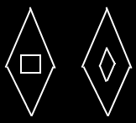

A clause will never redirect its definition or object to another command.

Clauses can have parameters, just like command definitions:

